L48 Rig Activity Capstone Proposal :

COVID-19 has changed the world as we know it in a permanent way. With countries around the world shutting massive metropolitan areas down, while workplaces are promoting remote work, everyone is trying to do their part to help contain the spread of the virus. Though many see these restrictions as necessary, they have crippled many parts of the economy, especially the service industries as would-be consumers stay home instead of venture out of their homes for daily commutes, work lunches, or date nights. Google Mobility data has suggested that on average worldwide mobility to workplaces, public transit stations, and retail have decreased around 24%, 35% and 30%, respectively [1].

With so many people staying at home and not using their vehicles, worldwide demand for consumption of oil has crashed with oil commodity prices following suit.

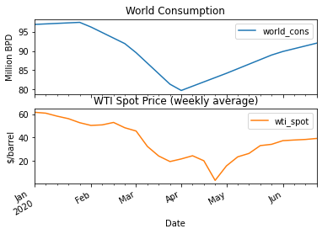 [2]

This created a crisis across the oil industry; operations that were profitable at $60 were no longer profitable at sub $20 prices. The US was specifically hit hard by this price crash; the oil and gas industry supported nearly 10.3 million jobs and added nearly 8% of the nation’s GDP in 2018 [3]. The exploration and production companies (E&P’s) could no longer afford to continue to drill and in turn the companies that had been providing services to the E&Ps could no longer afford to keep staff and massive layoffs started. The upstream oil and gas industry in Texas lost 12% of its workforce due to the layoffs in April alone [4].

The Baker Hughes Rig Count has been used as an industry standard to track upstream activity in the mainland US (also known as the US L48, not including Alaska, or Hawaii). The severity of this activity in the US can be shown by looking at the previous seven months of data.

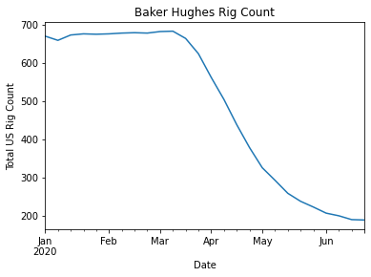

However, it’s not all doom and gloom for the US oil and gas industry. As the lockouts in many countries begin to lift, demand for oil will increase with more drivers on the road. The EIA is expecting demand for oil to rebound close to 2019 levels in 2021 [2]. With the price of oil improving to around $40 barrel, the rig count has yet to reflect that increase.

This leads to the following questions : when will the upstream industry begin a recovery in activity, and what factors influence it the most? Being able to predict the recovery could allow companies to get a head start on increasing staffing and investment levels to be able to take advantage of increased activity levels when other competitors are still on the upswing. Several factors will be analysed including worldwide and regional supply, demand and storage, OPEC spare capacity, oil prices, and oil futures trading, among others to predict and model the US L48 Rig Count.

**Citations :**

[1] API. “OIL &amp; NATURAL GAS: SUPPORTING THE ECONOMY, CREATING JOBS, DRIVING AMERICA FORWARD,” 2018. https://www.api.org/~/media/Files/Policy/Taxes/DM2018-086_API_Fair_Share_OnePager_FIN3.pdf.

[2] Baker Hughes. “North America Rig Count,” 2020. https://rigcount.bakerhughes.com/na-rig-count.

[3] Chapa, Sergio. “Texas Oil and Gas Industry Cut Record 26,300 Jobs in April,” May 26, 2020. https://www.houstonchronicle.com/business/energy/article/Texas-oil-gas-industry-shed-record-number-of-15294860.php.

[4] EIA. “U.S. Energy Information Administration - EIA - Independent Statistics and Analysis,” 2020. https://www.eia.gov/outlooks/steo/data.php.

[5] Google. “COVID-19 Community Mobility Report,” 2020. https://www.google.com/covid19/mobility/.